**DATABASE SYSTEMS**

**PROJECT**

**(CRIMINAL MANAGEMENT SYSTEM)**

**GROUP MEMBERS:**

**HASEEB TARIQ (70109359)**

**RAHEEL MUGHAL (70128174)**

**WALEED FAROOQ (70126890)**

**SUBMITTED TO: SIR ARMAN SOHAIL**

**1.ERD DIAGRAM:**

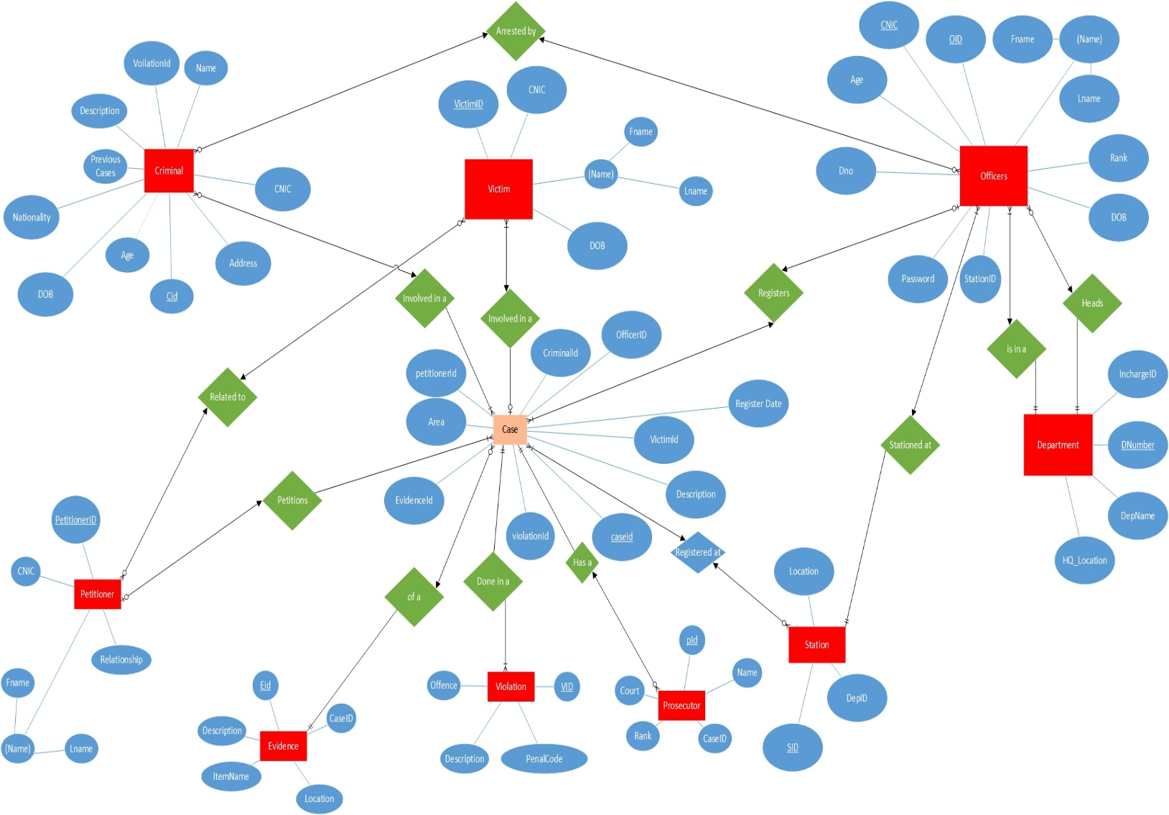

**2. RELATIONAL SCHEMA:**

